AGENT 4 – FINAL AI REPORTING AGENT
Goal
Central intelligence + performance optimization.

Flow:
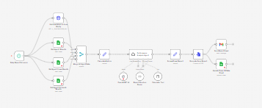
Step 1: Data Aggregation
Collect from:
- WordPress
- LinkedIn
- Klenty
- CRM
- Website Analysis
- Excel logs

Step 2: AI Analysis
Generate:
- Funnel performance
- Conversion rate
- CAC estimation
- Revenue forecast
- Channel performance
- Campaign ROI

Step 3: Final Report
Includes:
- Total Leads
- Emails Sent
- LinkedIn Connections
- Fit Clients
- SQL
- Revenue Projection

Step 4: Delivery
- Send PDF report via Email
- Update Power BI dashboards
Each agent has separate dashboard tab:
- Content Performance
- Inbound Qualification
- Outbound Campaign
- Revenue Forecast

